ALAGAPPA UNIVERSITY
FACULTY DETAILS

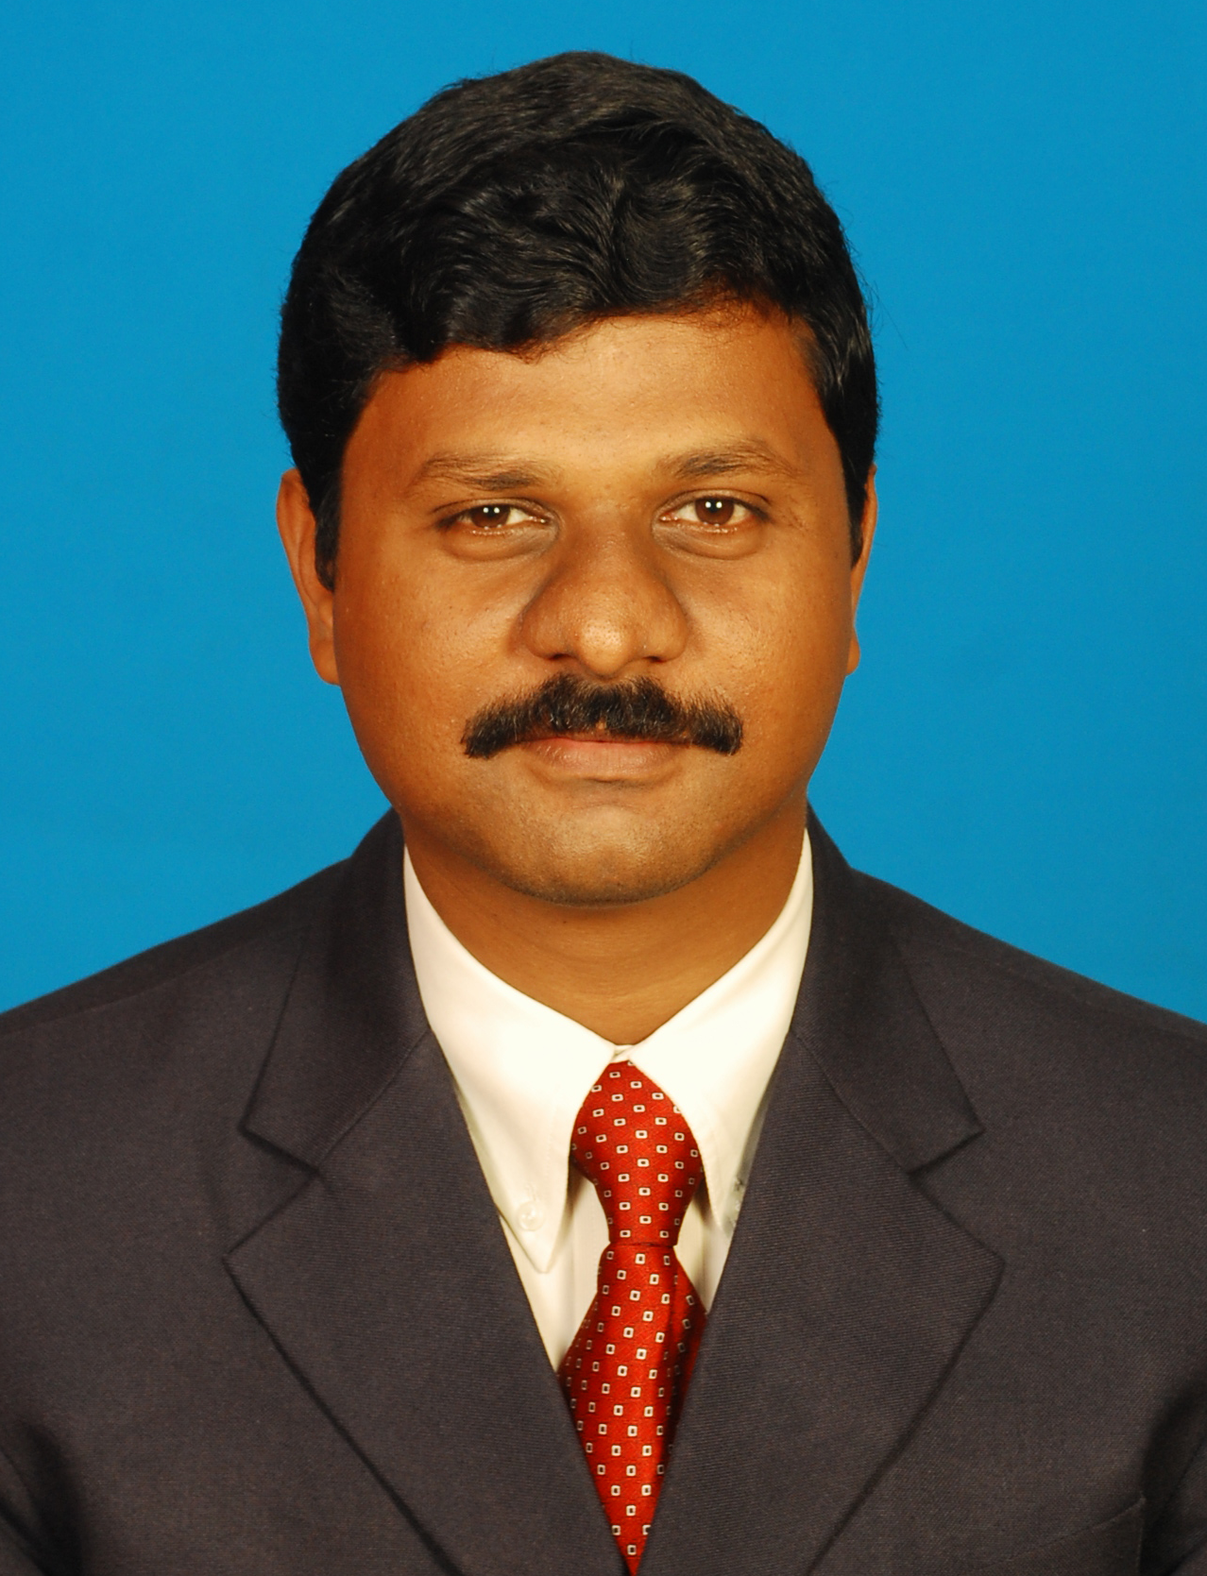 | Dr. K. CHANDRASEKAR
Date of Birth | 12.06.1977
Gender | Male
Department | Alagappa Institute of Management
Qualification | MBA, PGDIB, PGDHRM, M.Phil., Ph.D.,
Designation | Lecturer & Placement Officer
Address | Alagappa Institute of Management,  Alagappa University, Karaikudi.
Pin code | 630 004
Phone | 04565 – 225211, 9865630802
Email | chandrasekar77@yahoo.com
Website | www.aimkaraikudi.in
Fax | 04565 - 225202

University Studied UG and PG :

S.No | Degree | University | Year of Study
1 | BBA | University of Madras | 1995-1998
2 | MBA | University of Madras | 1998-2000
3 | PGDHRM | Pondicherry University | 1998-1999
4 | PGDIB | Pondicherry University | 1999-2000
5 | M.Phil.(Management) | Alagappa University | 2002-2003
6 | Ph.D.(Management) | Alagappa University | 2004-2006

University Where Research done :

Name of the University | Year of Study | Area of Specialization
Alagappa University | 2004-2006 | Human Resource

PG Specialization (subjects) :

1. Human Resource | 2. Marketing
3. Operations & Systems | 4.

Total Research Experience (No. of Years): 05

Total Teaching Experience (No. of Years):

S.No | Institution | Position | Period
S.No | Institution | Position | From | To
1 | Kovai Kalaimagal College, Coimbatore | Lecturer | June ’01-Mar. ’02
2 | Vysya Institute of Management Studies, Salem | Lecturer | April ’02-May ’03
3 | Alagappa Institute of Management, Karaikudi | Teaching-cum-Research Associate | June ’03-June ’05
4 | Mepco Schlenk Engineering College, Sivakasi | Lecturer | July ’05-Nov. ’06
5 | National Institute of Technical Teachers Training & Research, Chennai | Lecturer | Dec. ’06-Jan. ’08
6 | Alagappa Institute of Management, Karaikudi | Lecturer-cum-Placement Officer | Since Feb. 2008

Current Research Field :

1. Human Resource | 2. Entrepreneurship
3. Technology Management | 4.

No. of MPhil & PhDs Guided :

M.Phil | 5 | Ph.D | -

Seminar/Workshops Organized :

S.No | Title | Period
1 | Computer Skills Workshop for Bank Officials | 13th – 15th Feb. ’09
2 | Counselling & Training Programmes at NITTTR | Jan. ’07 – Dec. ’07
3 | National Seminar on Trends & Challenges in Entrepreneurial Training | 16th December 2005
4 | Faculty Development Programme on Entrepreneurship | 16th – 28th Feb. ’04
5 | Entrepreneurship Awareness Camps | Aug. ’03 – March ’05

Seminar/Workshops Attended :

(a) National :

S.No. | Title | Institution / Program Name | Period
1 | Corporate Ethics | Dept. of Corporate Secretaryship, Alagappa University, Karaikudi – National Seminar | 27th & 28th February, 2009
2 | Application of Multivariate Analysis in Business Research | Dept. of Business Administration, Annamalai University - Workshop | 22nd March 2008
3 | Student Counselling | NITTTR, Chennai - Workshop | 16th Feb. 2008
4 | Model Building Workshop of the A SEED PROJECT | Anna University, Chennai - Workshop | 2nd – 5th May 2007
5 | Instructional Design and Delivery System | NITTTR, Chennai - Faculty Development Programme | 26th Feb. – 10th Mar. 2007
6 | How to be a Better Teacher | ISTE Chapter, Mepco Schlenk Engineering College, Sivakasi - Workshop | 22nd Feb. 2006
7 | Marketing Management | Alagappa Institute of Management, Alagappa University, Karaikudi - Symposium | 18th March 2005
8 | Personality Development | Alagappa Institute of Management, Alagappa University, Karaikudi - Workshop | 04th Feb. 2005
9 | Entrepreneurship | CED, Madurai & Alagappa University - Training of Trainers programme | 29th Nov. – 03rd Dec. 2004
10 | Entrepreneurship | Alagappa Institute of Management, Karaikudi - Faculty Development Programme | 16th – 28th February 2004
11 | Current Business Scenario | Alagappa Institute of Management, Karaikudi - Conference | 05th Jan. 2004
12 | EDC Advisory Council | DST, NewDelhi & Bannari Amman Institute of Technology - Annual Meeting | 09th January 2004
13 | Overcoming Stress – The New Corporate Mantra | Sri Ramakrishna College of Arts & Science, Coimbatore - State Level Seminar | 01st March 2002

(b) International:

S.No | Title | Institution and Event Name | Period
1 | Industry-B.Schools Interaction Conference | XIME, Bangalore in Collaboration with KMA and Tie, Cochin - Conference | 15th September, 2008
2 | Pedagogical Tools in Marketing Management | T.A.Pai Management Institute, Manipal - QIP | 17th – 21st Nov.2005
3 | Teaching Methodology in Entrepreneurship | T.A.Pai Management Institute, Manipal - QIP | 03rd – 07th Jan.2005
4 | Mathematical Models for Business Decision Making | Jansons School of Business, Karumathampatti - Workshop | 18th December 2004

Papers Presented :

(a) National :

S.No | Title | Institution and Event Name | Period
1 | Advertisement Practices in India and Consumers Awareness towards Advertisements | Dept. of Management Studies, Kalasalingam University, Krishnankoil - National Seminar on Consumer Protection & Welfare | 17th & 18th December, 2008
2 | Role of Consumer Protection Act in Protecting Consumer Rights and Welfare | Dept. of Management Studies, Kalasalingam University, Krishnankoil - National Seminar on Consumer Protection & Welfare | 17th & 18th December, 2008
3 | The Magnitude of Sickness in SSI in India | ICSSR, SIDBI & Sree Saraswathi Thyagaraja College, Pollachi - National Seminar on Dimensions of Sickness in SSI Sector | 17th October, 2008
4 | The Problems and Challenges of Attrition in Information Technology (IT) Companies | Dept. of Management Studies, Valliammai Engg. College, SRM University, Chennai - National Conference on Transformation of Organizations in the Global Era | 24th September, 2008
5 | Perceptions and Attitudes of Employees Towards Change Management in Export Industries | Dept. of Management Studies, Valliammai Engg. College, SRM University, Chennai - National Conference on Transformation of Organizations in the Global Era | 24th September, 2008
6 | Work-Life Balance – A Sprouting Problem For Employees In Software Companies | Dept. of Management Studies, Valliammai Engg. College, SRM University, Chennai - National Conference on Transformation of Organizations in the Global Era | 24th September, 2008
7 | Impact of Globalisation on Restructuring of Developing Nations – A Study on Asian Countries | Alagappa Institute of Management, Alagappa University, Karaikudi – XXX-Indian Congress on Social Sciences | 26th – 30th Dec. 2006
8 | Quality Technical Education Through ICTs – Prospects & Problems | Mepco Schlenk Engineering College, Sivakasi - ISTE National Level Convention - Vibranz | 30th September 2006
9 | Services Retailing through Relationship Marketing | Alagappa Institute of Management, Alagappa University, Karaikudi - National Seminar on Retailing | 13th March, 2006
10 | Paradigms of New Perspectives in Services | Department of Management Studies, University of Madras, Chennai - National Seminar on Emerging Management Paradigms | 23rd, 24th February 2006
11 | Pedagogical Tools For EDP – Generation Ahead | Alagappa Institute of Management, Alagappa University, Karaikudi - National Seminar on Trends & Challenges in Entrepreneurial Training | 16th December, 2005
12 | Creative Process of Idea Management for Entrepreneurs | Alagappa Institute of Management, Alagappa University, Karaikudi - National Seminar on Trends & Challenges in Entrepreneurial Training | 16th December, 2005
13 | India’s Foreign Trade – The Competitive Trend | Department of Commerce & IB, Alagappa University, Karaikudi - National Seminar on Emerging Trends in India’s Foreign Trade | 16th March 2005
14 | The Globalized SSI Sector | P.R. Institute of Management, Thanjavur - National Seminar on Global Competitiveness – Trends & Traits | 25th February 2005
15 | Environmental Education – the need of the hour | KSR College of Arts & Science, Tiruchengode -National Workshop on Environmental Awareness | 30th June 2004
16 | Customer Relationship Management – A New Approach | Anna University & TVS Quality Centre, Chennai - National Seminar on Quality Management – QQuest | 14th - 16th March 2003
17 | Managing - Customer Acquisition & Retention Strategies | Annamalai University, Chidambaram - National Seminar on Customer Service Excellence | 12th ,13th March 2003
18 | Excellence in Customer Service Quality | Annamalai University, Chidambaram - National Seminar on Customer Service Excellence | 12th ,13th March 2003
19 | Customer Relationship Management | University of Madras, Chennai - National Seminar on Management in Transition | 21st, 22nd February 2003

(b) International :

S.No | Title | Institution and Event Name | Period
1 | Foreign Direct Investment – The Fortune of India’s Economic Growth | School of Management, Alagappa university, Karaikudi - International Conference on Global Economic Ascendance Realm | 31st march 2009 – 2nd April 2009
2 | The Integrative Supply Chain Strategies towards Customizing & Enhancing of Marketing Deliverables | School of Management, Alagappa university, Karaikudi - International Conference on Global Economic Ascendance Realm | 31st march 2009 – 2nd April 2009
3 | The Contemporary Knowledge Management – The Recessional Challenges & Charms | KSR School of Management, Tiruchengode - International Seminar on Managing Global Recession – Opportunities & Challenges | 25th March, 2009
4 | Total Quality Education – Revitalising University Education System | Centre for Continuing Education, Indian Institute of Science, Bangalore - International Conference on Higher Education (ICHE-07) | 12th – 14th July, 2007
5 | HR Outsourcing – Beyond Productivity | Department of Management Studies, Indian Institute of Science, Bangalore - International Conference ‘COSMAR 2005’ | 22nd – 24th September 2005
6 | Entrepreneurial Thrust in the Globalised Era – A Focus on the Developing Nation | Adaikalamatha Institute of Management, Thanjavur - International Conference on Global Business & Policy Modelling | 21st & 22nd September 2006
7 | Critical Review of Assessment Centres – An Approach for Employee Development | Adaikalamatha Institute of Management, Thanjavur - International Conference on Global Business & Policy Modelling | 21st & 22nd September 2006

Papers Published :

(a) National :

S.No | Paper Title | Name of Journal, Volume No and Page | Year Publication
1 | Does the Technical Institutions provide Quality Technical Education in India | Indian Journal of Technical Education, Vol.31 | Nov.’98
2 | Functioning of Assessment Centres – The Rationale Behind Employee Development | Indian Journal of Training and Development Vol. XXXVI, No.4 | July’99
3 | Consumers’ Attitude Analysis towards Reading Newspapers & Magazines in Nagapattinam District, Tamilnadu | Indian Journal of Marketing – Vol.36, Pg. 27-32 | July-December 1999
4 | Customer Acquisition & Retention Strategies – the Relational Perspective | ICFAI Journal of Marketing Mastermind - Pg. 9-14 | September 1999
5 | Potential Appraisal – beyond the performance | HRD Times – Vol.7, Pg.17-18 | Dec’99
6 | Employee Evaluation | HRD Times – Vol. 6, Pg. 20-22 | Mar-00
7 | Foreign Exchange Management in Indian Markets | Current TaxCom News – Vol. 17, Pg. 818-822 | Apr’00
8 | Pedagogical Tools for EDP – Generation Ahead | ICFAI Journal of Entrepreneurship Development | June ‘00
8 | Pedagogical Tools for EDP – Generation Ahead | ICFAI Journal of  Entrepreneurship Development | Accepted for publication

(b) International :

S.No | Paper Title |  | Name of Journal, Volume No and Page | Year Publication
1 |  | Employee Empowerment through Total Quality Management | International Journal of Development Studies | accepted for publication

Books Published / Course material written :

S.No | Title | Publisher | Year
1 | Entrepreneurial Training – Theory & Practice | Kanishka Publishers Distributors, NewDelhi | 2007
2 | Role of Consumer Protection Act in protecting Consumer Rights - Consumer Protection & Welfare | Kalasalingam University & SNAM Publishing House, Chennai | December 2008
3 | Consumer Behaviour for MBA-Marketing | DDE, Pondicherry University | 2006
4 | Global HR Practices for MBA-HRM | DDE, Pondicherry University | 2007
5 | Services Marketing for MBA | DDE, TN Sports & Physical Education University | 2008

Exposures as Resources persons/ Chairpersons, etc :

S.No | Name of Conference / Seminar/ Workshop | Institution and Place | Date
1 | Training to Selected Entrepreneurs under PMRY Scheme | Regional Training Centre, IOB, Karaikudi | 6th & 7th August 2009
2 | Counselling & Training Programmes for the Technical Teachers | NITTTR, Chennai, Hyderabad, Cochin | Jan. ’07 – Dec. ’07
3 | Seminar on Entrepreneurship Awareness | Pattukkottai Polytechnic College, Pattukkottai | 18th March 2004
4 | Special Lecture on Self Employment for Women | Community Polytechnic Scheme, Alagappa Polytechnic College, Karaikudi | 29th June 2004
5 | Entrepreneurship Awareness Camps | Alagappa Polytechnic, Alagappa Govt. Arts College, Annamalai Polytechnic, Mount Zion College of Engineering & Subramanian Polytechnic, Karaikudi | Sept. ’03 – Sept. ’04
6 | Distance Learning Program Contact Seminars | Alagappa University, Annamalai University, TN Open University | Every year

Membership in Professional Bodies :

S.No | Name of the institution and place | Capacity / Status
1 | Indian Academy of Applied Psychology, Kolkata | Life member
2 | Indian Society for Technical Education, NewDelhi | Life member
3 | Indian Academy of Social Sciences, Allahabad | Associate Fellow member

Additional Administrative Positions Held :

S.No | Position | Period
S.No | Position | From | To
1 | Editorial Member, University Newsletter (AZHAGU) | From June 2008

